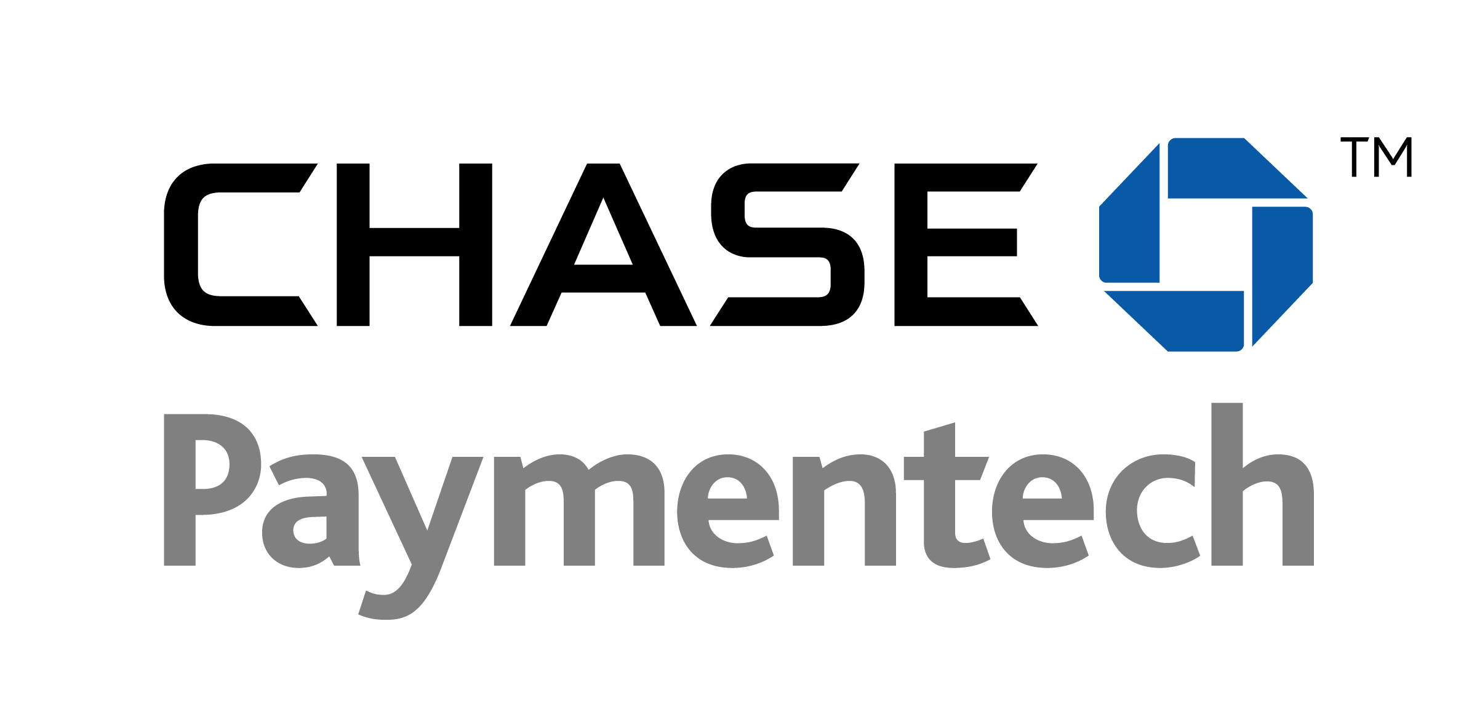

VeriFone

ECRi

May 13 2013

Table of Contents

Overview 3

1.1. What is ECRi? 3

1.2. How does it work? 3

1.3. Key Features 4

1.4. Support Devices 4

2. Getting Started 5

2.1. Ordering your Development Kit 5

2.2. Obtaining your cable 5

2.3. Testing 6

2.4. Deployment 8

3. Resources and Support 9

3.1. Card simulator and advanced training 9

3.2. Sales and Development Support 9

3.3. Production Support 9

4. FAQ 10

Overview

* 1. What is ECRi?

Chase Paymentech has partnered with VeriFone to deliver a new point-of-sale middleware to assist software vendors and merchants in achieving EMV compliance. A full EMV certification is a time-consuming and costly process and is required whenever changes are made to the system.

The Electronic Cash Register interface (ECRi) offers developers the capability to communicate with a stand-alone POS. Because Chase Paymentech is certifying and maintaining the compliance of the payment application loaded on the POS terminal, only a registration is required from the partners or merchants.

* 1. How does it work?

The cash register communicates with the Vx810, Vx820 or Vx520 VeriFone terminal.  
The VeriFone terminal is connected directly to Chase Paymentech and communicates to the ECR only to provide generic transaction information.

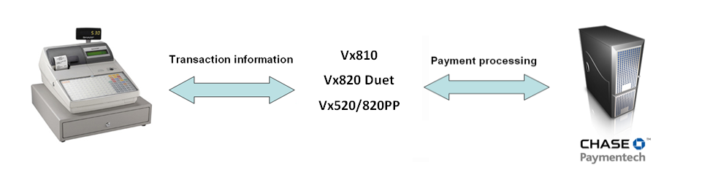

In this environment, all the payment information resides on the VeriFone terminal and the ECR is acting as the initiator of the transaction.

* 1. Key Features
* Transactions may be initiated by the ECR or directly on the VeriFone terminal
* Supported transaction types include:
  + Sale (may include tip amount in addition to base amount)
  + Refund
  + Offline Sale (Force Post)
  + Phone Order
  + Void
* Card types supported:
  + Credit
  + Debit
  + Chase Paymentech Gift Card programs
  + Interac, Visa, MasterCard EMV
  + Contactless
* Reprint of receipts, all reports and settlement must be initiated on the VeriFone device - no ECR initiation is supported
* Canceling the transaction must be initiated at the VeriFone terminal
* The ECRi will not support any serially connected peripheral devices, such as external PIN pads or external contactless readers (the VeriFone Contactless Module IS supported)
* Official Receipt is printed from the VeriFone device

**1.4. Supported Devices**

Vx820 Duet with USB and Serial support

Vx520 and Vx820 PIN Pad combo with Mini USB support

Vx810 Duet with USB to RS232 and Serial to RS232 support

1. Getting Started
   1. Ordering your Development Kit

Chase Paymentech created a development kit that contains all you need to start your development. This kit is available for $850.00 ($970.00 if including contactless module – Vx810 only) and will be delivered within 5 business days after reception of the ECRi DevKit Request.doc.

In order to start your development you will need:

* 1 Vx810 Duet, Vx820 Duet or a Vx520 with a Vx820 PIN Pad and the ECRi Application installed
  + You can choose retail or restaurant set-up
  + The Vx810 and Vx820 Duet terminal will only have internal PIN pad capabilities and the Vx520 will have the Vx820 External PIN Pad attached.
* The VeriFone ECRi Reference Guide
* Test cards
  1. Obtaining your cable

Chase Paymentech will provide the cables needed to connect the POS terminal to the ECR.

* 1. Testing

Chase Paymentech requires that the communications between the ECR and the POS terminal is thoroughly tested to ensure that the expected behavior is achieved.

Please see the attached script for assisting with the testing of the integration between the POS and the ECRi device.

|  |  |  |  |  |
| --- | --- | --- | --- | --- |
| # | Card | | Tran Description | Amount |
| 1 | Visa | | Swipe | 12.00 |
| 2 | Visa | | Manual w/ AVS, CVD | 38.00 |
| 6 | MC | | Swipe | 11.00 |
| 7 | MC | | Manual w/ AVS, CVD | 25.00 |
| 8 | Amex | | Swipe | 55.00 |
| 9 | Amex | | Manual w/ AVS, CVD- illegible | 75.00 |
| 10 | Discover | | Swipe | 10.00 |
| 11 | Discover | | Manual w/ AVS-zip only | 63.00 |
| 12 | Diners | | Swipe | 22.00 |
| 13 | Diners | | Manual | 14.00 |
| 14 | Refund - Visa | | Swipe | 52.00 |
| 15 | Refund - MC | | Manual | 75.00 |
| 16 | Refund - Amex | | Manual | 103.00 |
| # | Card | | Tran Description | Amount |
| 17 | Refund - Discover | | Swipe | 42.00 |
| 18 | Refund - Diners | | Manual | 59.00 |
| 19 | Debit Sale | |  | 50.00 |
| 20 | Debit Sale, $20.00 cash back, $1.50 surcharge | |  | 68.00 |
| 21 | Debit Sale | |  | 85.00 |
| 22 | Debit Sale, $15.00 cash back | |  | 40.00 |
| 23 | Debit Sale, $3.00 Surcharge | |  | 18.00 |
| 24 | Debit Sale (please use card# 5892971305421622591) | |  | 19.68 |
| 25 | MAC Reversal | |  | 19.68 |
| 26 | Debit Return | |  | 20.00 |
| 27 | Debit Return, $2.00 surcharge (please use card# 5892971305421622591) | |  | 19.68 |
| 28 | MAC Reversal | |  | 19.68 |
| 29 | Debit Return | |  | 25.00 |
| 30 | Debit Sale Void | |  | 50.00 |
| 31 | Debit Return Void | |  | 25.00 |
| 32 | Stored Value | 70 = Issuance/Add Value | Swipe | 16.00 |
| 33 | Stored Value | 70 = Issuance/Add Value w/CVD | Manual | 30.00 |
| 34 | Stored Value | 71 = Activation | Swipe | 25.00 |
| 35 | Stored Value | 71 = Activation w/CVD | Manual | 50.00 |
| 36 | Stored Value | 72 = Block Activation of 5 cards ($30 EACH) | Manual | 150.00 |
| # | Card | | Tran Description | Amount |
| 37 | Stored Value | 73 = Redemption | Swipe | 98.00 |
| 38 | Stored Value | 73 = Redemption w/CVD | Manual | 40.00 |
| 39 | Stored Value | 73 = Redemption | Swipe | 56.00 |
| 40 | Stored Value | 78 = Void – trx #2 from above | Manual | 30.00 |
| 41 | Stored Value | 79 = Balance Inquiry |  |  |
| 42 | Stored Value | 78 = Void – trx #8 from above | Swipe | 56.00 |
| 43 | Stored Value | 70 = Issuance/Add Value | Swipe | 16.00 |
| 44 | Stored Value | 82 = Deactivation | Swipe | 0.00 |
| 45 | Stored Value | 82 = Deactivation | Manual | 0.00 |
| 46 | Stored Value | 83 = Reactivation | Swipe | 35.00 |
| 47 | Stored Value | 83 = Reactivation w/CVD | Manual | 25.00 |
| 48 | Stored Value | 72 = Block Activation of 10 cards ($25 each) | Manual | 250.00 |
| 49 | Stored Value | 72=Block Activation of 150 cards ($10 each) | Manual | 1500.00 |
| 50 | Stored Value | 72= Block Activation of 200 cards ($10 each) | Swiped | 2000.00 |

* 1. Deployment

Once your development is complete you must fill out the registration form and submit to [PTI-CanadianSalesSupport@ChasePaymentech.com](mailto:PTI-CanadianSalesSupport@ChasePaymentech.com). Once we’ve received the registration form, a letter of approval/registration will be sent and you can start deploying the ECRi solution to merchants. This solution will be deployed like a standard VeriFone stand alone terminal and the merchant will have to request ECRi as an additional set-up.

1. Resources and Support
   1. Card simulator and advanced training

Chase Paymentech provides one set of EMV test cards (Visa, Mastercard, Interac) with each Vx810 Duet terminal that is purchased. The default card package is English; however French cards may be substituted. Additional card packs are available for $250 each.

B2 or ICC may also be contacted to provide EMV test tools, card packs and advanced training.

Bruce Murray  
B2 Processing Solutions  
416-730-9827 x1  
[bruce.murray@b2ps.com](mailto:bruce.murray@b2ps.com)

Dave Maisey  
ICC Solutions Limited  
416-304-3937  
DaveMaisey@iccsolutions.com

* 1. Sales, Development and Testing Support

Chase Paymentech’s Retail Sales Consulting team can help you better understand and position the ECRi solution to your clients. Once the registration form has been completed Chase Paymentech’s Retail Consulting team will provide the approval/registration letter. If you have any questions, contact us at:

[PTI-CanadianSalesSupport@ChasePaymentech.com](mailto:PTI-CanadianSalesSupport@ChasePaymentech.com)

* 1. Production Support

For production support or if the terminal is not working properly, contact our Technical Support team at:

[Tor-MerchantTechnicalSupport@chasepaymentech.com](mailto:Tor-MerchantTechnicalSupport@chasepaymentech.com)

1. FAQ

**Do I need to complete an EMV certification?**

No. The EMV certification with the card association was completed by Chase Paymentech for the payment application. Because the ECRi just communicates to the terminal to initiate the transaction, this does not require an EMV certification.

**How long does it take to develop the connectivity between my ECR and the POS terminal?**

During our testing period, we have seen software vendors completing their development within 2 weeks and start installing on week 3.

**Are the Verifone devices the only devices available?**

Yes.

**Can I add a contactless reader?**

Yes. Contactless is available using the VeriFone Vx810 Duet with an optional contactless module. The Vx520/820 and the Vx820Duet have contactless built in by default.

**What are the terminals communication methods available for authorization?**

The communication methods can be dial or IP with an optional dial back-up option.

**If the connection to the ECR fails, can the merchant use the terminal as a stand-alone terminal?**

Yes. This is one of the benefits of this set-up.

**What cables are provided by Chase Paymentech?**

One Ethernet Cable

One Power Cable

One Telephone Cable

One Serial or USB Cable

**Can I use USB connectivity?**

Yes. The Vx520 uses a standard Mini USB cable and the Vx820 Duet uses a cable provided by VeriFone.

**Note:** For the Vx820 Duet a USB driver needs to be installed on the Cash Register.

## Vx820 USB Drivers Download page: -

## Countertop solution > Drivers > USB Drivers All VX Devices

<http://support.verifone.com/verifone/support/contentView.do?channelId=-43019&programId=478239&categoryId=-45018>